Event Development Timeline
ICE Actions and Public Response (2025.1.1 – 2026.1.18)
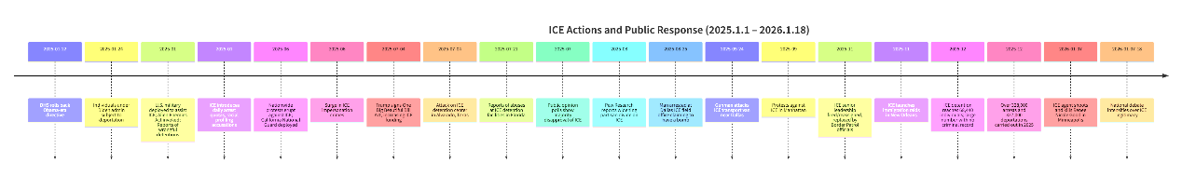
January 2025 — Policy Reversal and Federal Escalation
- Jan 22, 2025:
The Department of Homeland Security announced the rollback of an Obama-era directive that had previously limited immigration enforcement in so-called sensitive locations, including hospitals, places of worship, schools, courtrooms, funerals, and weddings.
- Jan 24, 2025:
Acting Secretary of Homeland Security Benjamine Huffman stated that individuals who had been temporarily admitted into the United States under the Biden administration would now be subject to deportation.
- Early 2025:
The U.S. military was deployed in multiple states to assist ICE operations. The administration invoked the Alien Enemies Act to accelerate deportations with minimal due process, including transfers of detainees to prisons in El Salvador. Reports emerged of U.S. citizens being detained or deported, triggering legal challenges and widespread criticism from legal scholars and civil rights organizations.
- During this period, ICE introduced daily arrest quotas and pursued a deliberate strategy to increase the public visibility of arrests. Federal courts later found evidence of racial profiling, with ICE accused of disproportionately targeting “Hispanic-looking” individuals.
June 2025 — Nationwide Protests and Militarized Policing
- June 2025:
Large-scale protests against ICE and mass deportation policies erupted nationwide, most prominently in Los Angeles, where the California National Guard was deployed with riot shields.
- Legal and law enforcement experts warned that ICE’s increased use of plainclothes arrests led to a surge in ICE impersonation crimes across the country, raising public safety concerns.
July 2025 — Funding Expansion, Abuses, and Violent Incidents
- July 4, 2025:
President Trump signed the One Big Beautiful Bill Act into law, allocating unprecedented funding to ICE—more than any other federal law enforcement agency in U.S. history, and more than the federal prison system. Funds were designated for detention expansion, deportation operations, and agent recruitment, including a $50,000 signing bonus and $60,000 student loan forgiveness.
- July 4, 2025:
A group attacked an ICE detention center in Alvarado, Texas, marking the first of several violent incidents targeting ICE facilities that year.
- July 21, 2025:
The Guardian reported on alleged abuses at ICE detention facilities in Florida, nicknamed “Alligator Alcatraz.” Advocacy organizations documented reports of detainees being deprived of food, water, and showers. Multiple deaths in ICE custody were reported during the first months of Trump’s second term.
- By July 2025:
Public opinion polls showed majority disapproval of ICE, exceeding negative sentiment during the 2018 “Abolish ICE” movement.
August–September 2025 — Polarization and Escalating Violence
- Late August 2025:
Pew Research Center reported a sharply widening partisan divide:
  - 72% of Republicans viewed ICE favorably
  - 78% of Democrats viewed ICE unfavorably
- August 25, 2025:
A man was arrested at a Dallas ICE field office after claiming to have a bomb.
- September 24, 2025:
A gunman fired on an ICE transport van near the Dallas field office, killing one detainee and critically injuring two others before committing suicide. One injured victim later died.
- September 2025:
Protests against ICE and mass deportation took place at Federal Plaza in Manhattan, reflecting continued nationwide mobilization.
November–December 2025 — Institutional Shakeup and Intensified Raids
- By November 2025:
At least half of ICE’s senior leadership was fired or reassigned, with many positions filled by Border Patrol officials. Media analysis suggested this reflected the administration’s push for more aggressive, less targeted enforcement methods.
- Late November 2025:
ICE launched a series of immigration raids in New Orleans, drawing criticism from local officials and prompting calls for transparency and interagency coordination.
- December 2025:
ICE detention reached 68,440 individuals, nearly 40,000 of whom had no criminal record or only pending charges.
From January to December 2025, over 328,000 arrests and 327,000 deportations were carried out.
January 2026 — Minnesota Shooting and National Crisis
- January 7, 2026:
An ICE agent shot and killed 37-year-old Renee Nicole Good in her car in Minneapolis, Minnesota, during an enforcement-related incident involving Somali community members.
- The shooting triggered immediate and widespread anti-ICE protests. President Trump threatened to invoke the Insurrection Act of 1807 to deploy federal troops to Minneapolis.
- January 7–18, 2026:
The incident intensified national debate over ICE’s legitimacy, use of force, and role as a federal coercive institution, marking a critical escalation point in public and media discourse.

